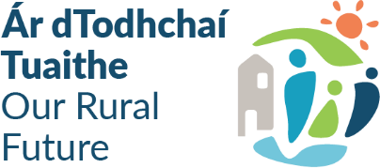
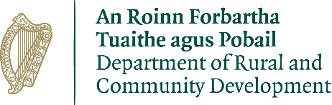
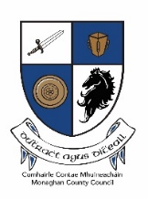
Community Recognition Fund 2024
The funding is specifically targeted at projects that are located in communities, towns and villages that are hosting the Beneficiaries of Temporary Protection and/or International Protection Applicants (‘new arrivals’) including towns identified for the rapid build homes programme. The Fund aims to support the development of facilities that will be used in the future by all members of the community. It is separate in its objectives and scope to any other public funding streams which aim to support the development of public service needs arising from the significant number of arrivals from Ukraine and other countries.

The Community Recognition Fund was first introduced in 2023 to recognise the huge efforts made by communities in welcoming and supporting people coming to Ireland. Based on the continued impacts on communities throughout the country and the need to support these communities in welcoming new arrivals, a further €50 million is being provided under the Community Recognition Fund 2024.

Monaghan County Council has received an allocated of €914,972.

The proposal must demonstrate that the funding is targeted at, and specifically invested in, those communities, villages and towns where the highest level of new arrivals are located and where there is a clear need for investment identified.

Projects situated in areas that do not have high levels of new arrivals will not be eligible for funding under the Community Recognition Fund 2024.

Projects to be funded will be capital in nature, deliver medium-long term benefits for the communities in which they are located, and be capable of being delivered over the course of 2025 and 2026. A minimum spend of 50% of the allocation must be incurred in 2025. Eligible projects will receive funding for capital costs, but not for any ongoing operational or running costs.

The minimum level of funding for an individual project is €50,000 with a maximum of €500,000 applying. Smaller projects cannot be artificially combined to meet the minimum threshold of €50,000 – while the 2023 scheme provided funding for small scale investment in clubs and communities (e.g. for small scale equipment), the focus of the 2024 scheme is on projects of greater scale and impact.
Local authorities have scope to invest the funding based on their own distinct local needs as identified through a “bottom-up” approach and based on the community engagement.

However, the type of projects eligible for funding are:
- development, enhancement or refurbishment of community or cultural facilities including play areas, walkways, parks, community/sensory gardens, allotments, and recreational areas;
- development, enhancement or refurbishment of local club and sports facilities including facilities such as community swimming pools, changing rooms, toilets, digital aids such as score / information boards etc.;
- enhancement to school/parish facilities which are open to use by all of the community after school hours;
- purchase of equipment for local clubs, festivals, community events and organisations e.g. music, arts or sports equipment;
- transport infrastructure such as the purchase of community vehicles, bus shelters and attendant information boards; (any vehicle funded must be in good condition and not more than 5 years old)
- projects that help address dereliction and/or wider local economic and community development objectives;
- purchase and refurbishment of vacant or derelict buildings for community use where a clear need is identified.
- Purchase of land and associated works for the development of community facilities such as play areas/ MUGAs or town parks/ community gardens, recreational areas etc. (purchases must only be administered by the local authority).

Application Process
- Ensure that the application form contains as much information, is fully completed with all questions answered.

- Only towns & villages that are hosting high levels of the Beneficiaries of Temporary Protection or International Protection Applicants are eligible for this funding.

- Ensure accurate costings at application stage.

- Projects must be able to be completed within the required timeframe.

- Projects should be shovel ready with all permissions in place or at an advanced stage at the time of funding approval. 50% of project costs must be incurred in 2025 with the project completed in full by 2026.

Online Consultation Process

Groups and Organisations are encouraged to submit

In-person Information Sessions

Staff from Monaghan County Council will be available to meet with groups and organisations to discuss and advise on their proposals. These information sessions will be held in the following areas:

- The Courthouse, Clones on
- Teach na nDaoine, Monaghan
- The Chamber, Carrickmacross Civic Offices

Further information on the funding application process will be available on Monaghan County Council’s website in the coming weeks. As part of the process, the council intends to set up a number of workshops around the county to engage with host communities and assist them in identifying projects that might be eligible for funding under the scheme.

